

JACKSON NORDIC RACES
Feb 8-9th
Schedule:

Friday, February 8th - 10km Classic:
9:00 a.m. Bibs available at Trail Creek Cabin, race scratches due into Matt Herr.
10:30 a.m. Varsity Boys 10km Mass Start
11:15 a.m. Varsity Girls 10km Mass Start
12:05 p.m. JV & JH Boys 4km Mass Start
12:30 p.m. JV & JH Girls 4km Mass Start

Saturday, February 9th – Freestyle Sprints:
7:30 a.m. Bibs available at Trail Creek Cabin, race scratches due into Walt Berling.
8:50 a.m. Course closed. Lower field trails open for warm ups. We will have signs point the way.
9:00 a.m. Races start
-Varsity Girls’ Sprint Heats-3 heats of 7 racers
-Varsity Boys’ Sprint Heats-3 heats of 7 racers

-JV Girls’ Sprint Heats-2 heats for all racers
-JV Boys’ Sprint Heats-2 heats for all racers

-Varsity Girls’ A Semifinals
-Varsity Girls’ B Semifinals
-Varsity Boys’ A Semifinals
-Varsity Boys’ B Semifinals

-Varsity Girls’ B Finals
-Varsity Boys’ B Finals
-Varsity Girls’ A Finals
-Varsity Boys’ A Finals

Awards to follow 15 minutes after the Varsity Boys’ A finals.

Race Details:

Friday’s race will be a mass start with 7 lanes; one per team (Red Lodge will be racing in Cody’s lane). Racers within each team can determine the lane order. In the JV mass start, the Junior High racers will be placed behind the JV in a free-for-all format (first come first serve).

Saturday’s race will begin at 9am with heats running continuous throughout the day with short breaks marked by the line gaps in the Freestyle sprint schedule above. Might be chaotic but should be fun. Who knows, Walt’s running it.

Course Inspection and Warm-up:

Please, no skiing backwards on the course. Friday, the course won’t be closed but be aware of start times and watch for racers on the course when warming up. Saturday, the sprint course will be closed but there will be access to skiing in the lower part of the field.

Driving and Parking:

Trail Creek is a nightmare in terms of parking. Bus drop offs for all the teams are allowed but the drop off area can only fit several busses at a time, please arrive early and be patient. Have your school bus drive to the end of Old Pass Rd to the parking lot for turn around. On the way back through, drop off the kids and equipment at Trail Creek. The bus can park at Teton Village Road Transit Center (On Beckley Park Way, northwest of the junction of rte 22 and rte 390 which is at the stoplight between Wilson and Jackson). Please send out an email to parents telling them to park at the Teton Village Road Transit Center as well. There will be a High School shuttle bus running between there and Trail Creek from 9am to 2pm on Friday and 8am to 2pm on Saturday.

Food and Amenities:

Water, chocolate milk, orange slices and cookies will be available for racers at the finish. Other than that, athletes must provide their own food since we don’t have a food and beverage stand like Casper.

Coaches, there will be coffee and hopefully snacks for the volunteers (depends on what we can get donated) in the cabin. You’re welcomed to it but please keep it our secret since we don’t have enough for everyone. Thanks.

Porta-Potties will be available near the cabin.

Trail Maps:
Friday’s Classic 5km Loop (it will be marked out on Thursday):
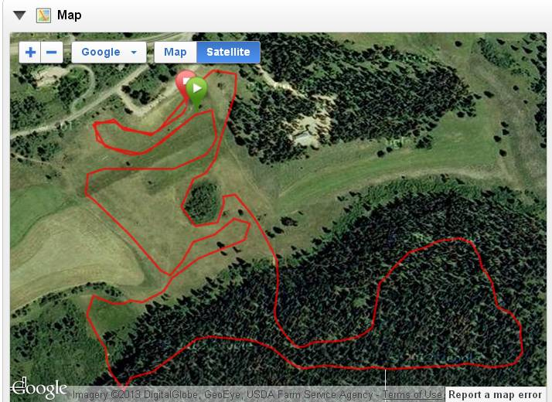

Friday’s Classic Stadium Layout: `

Saturday’s Sprint Course:

